**E-Commerce Product Service**

**Service for managing products in the E-Commerce platform**

**REST API Results**

API: getProductById **GET**

API Response:

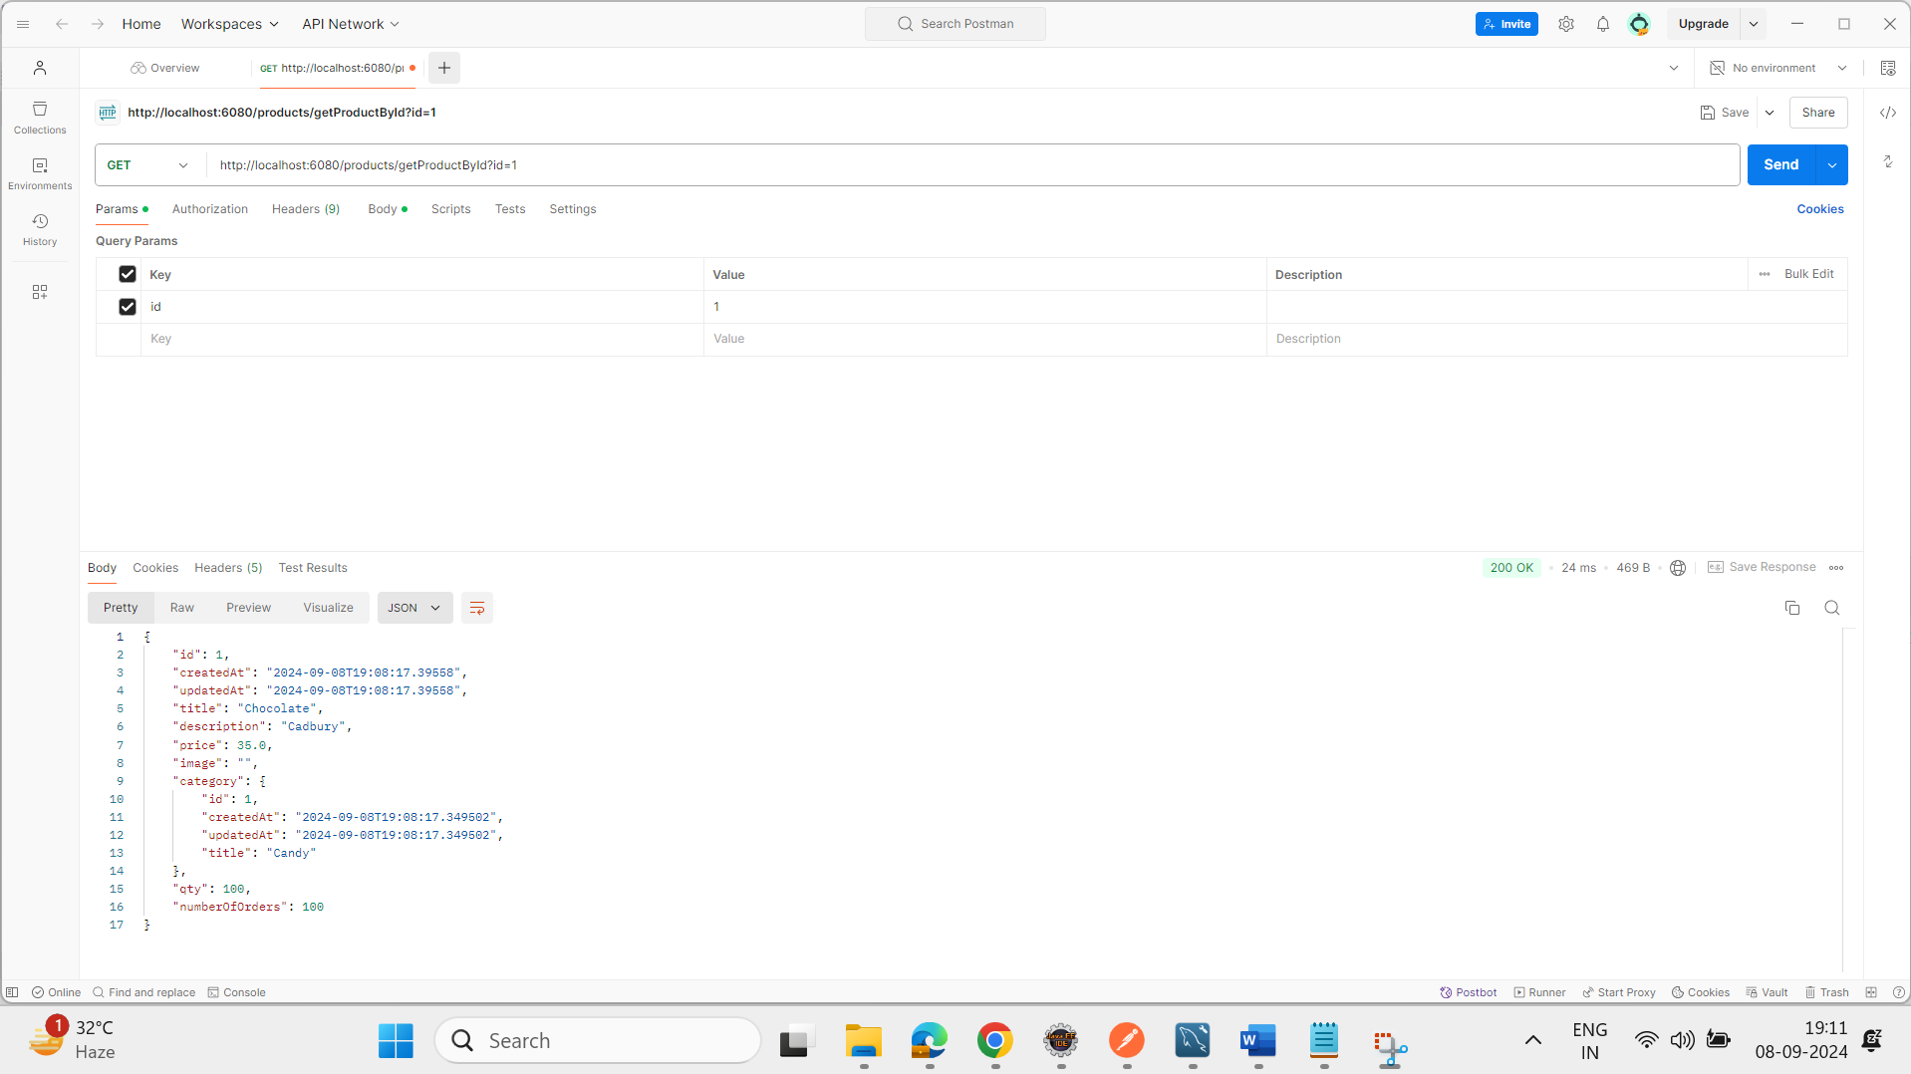

API: updateProductPriceById **PATCH**

API Response:

API: getAllProducts **GET**

API Response:

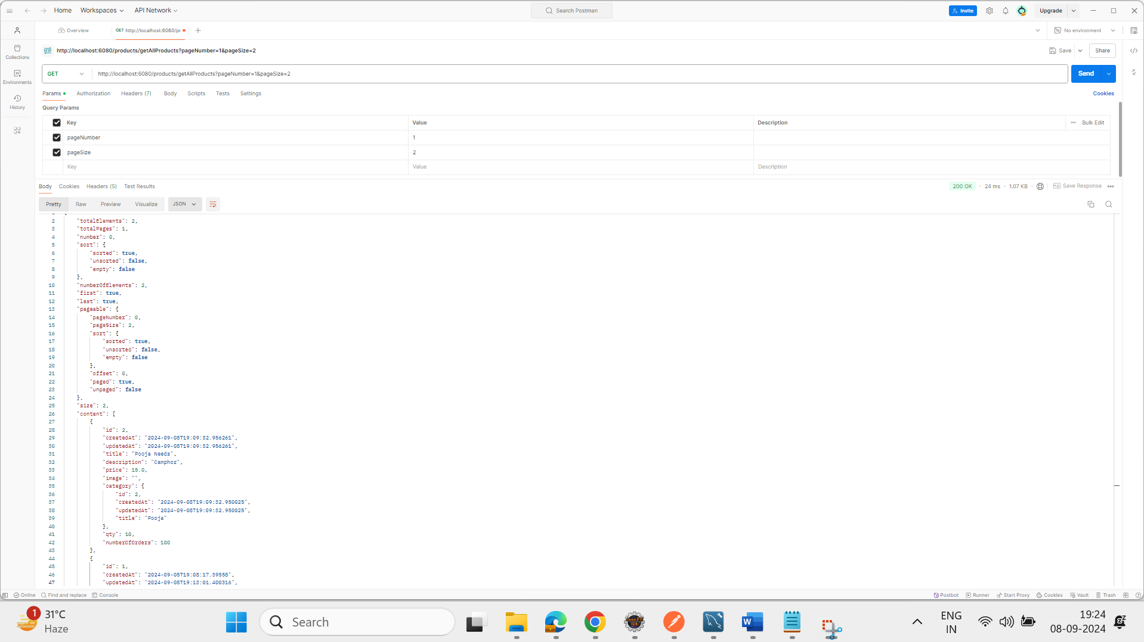

API: postProduct **POST**

API Response:

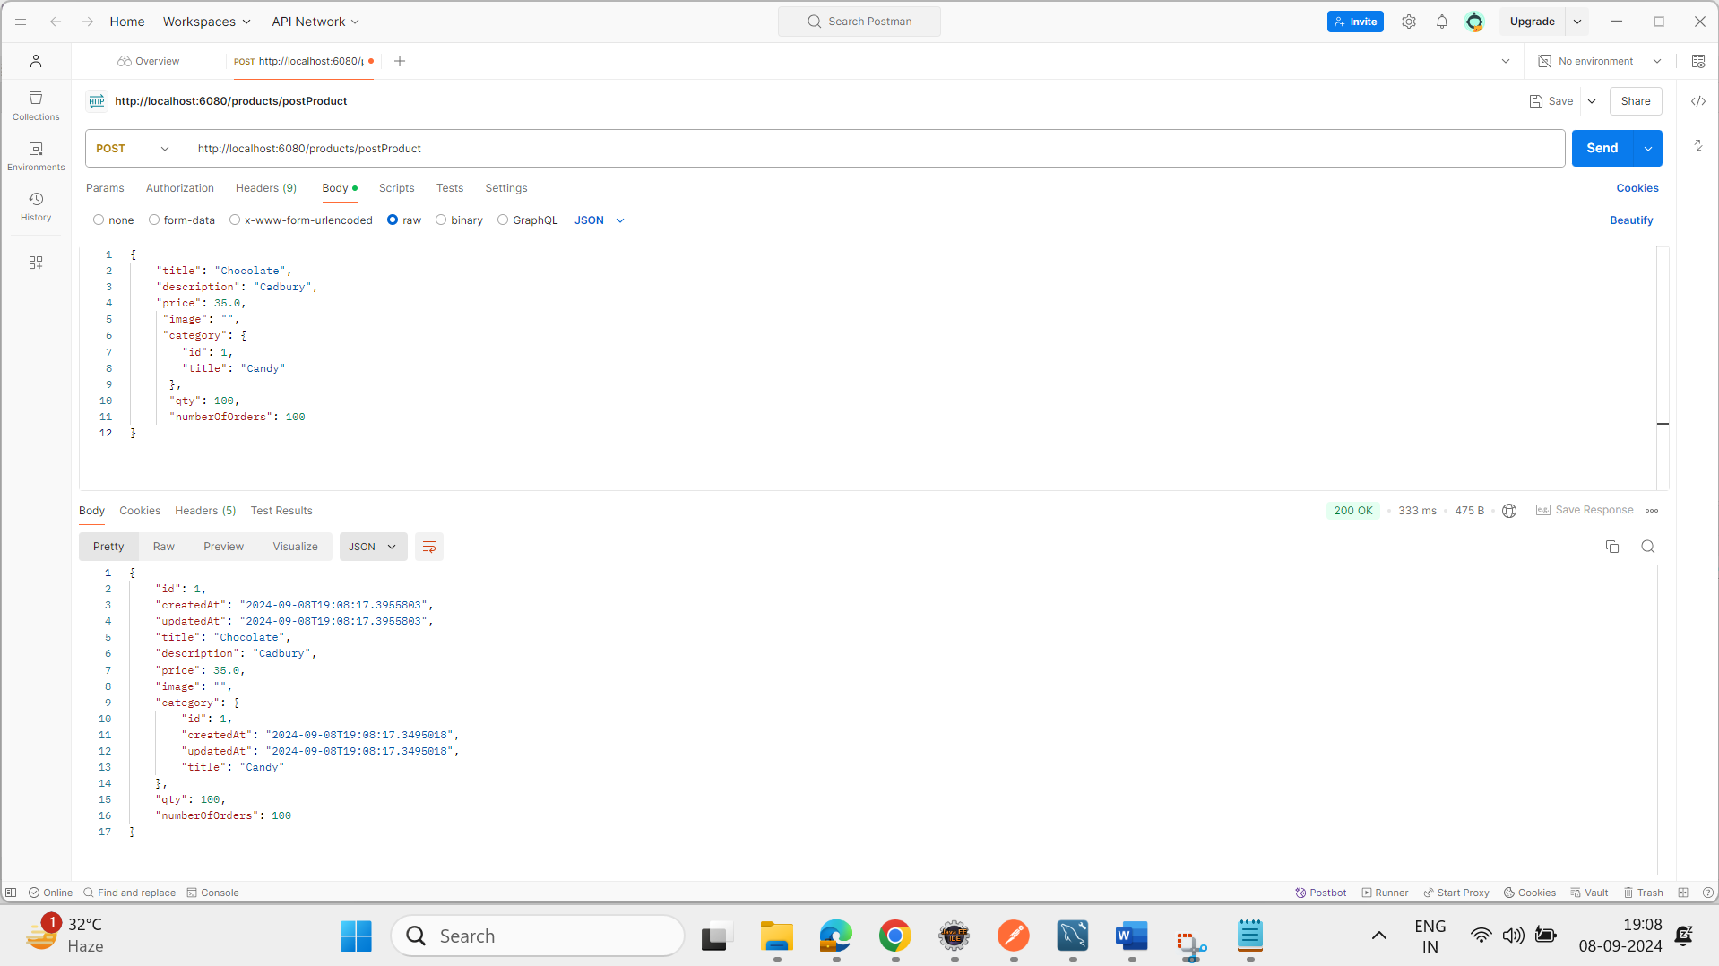

API: putProduct **PUT**

API Response:

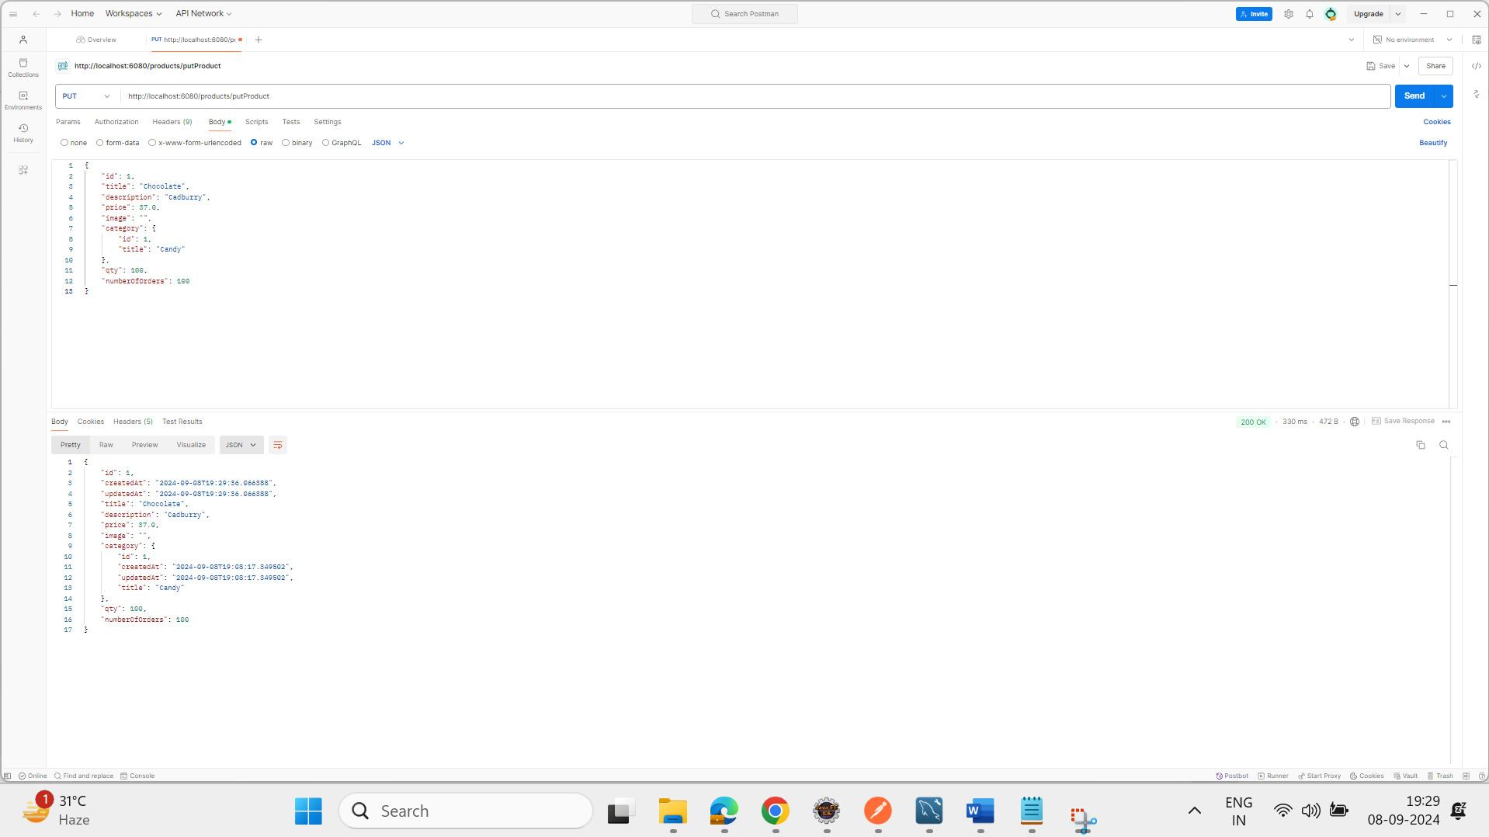

API: deleteProductById **DELETE**

API Response:

Category remains exists and only product data alone will get deleted.

